244th Ave NE/SR 202 – Issue summary and report – January 19, 2022
Location:
244th Ave NE near Redmond Fall City Rd, (SR-202).
Issue:
In winter 2020, a slide occurred on the downhill slope of 244th Ave NE. The slope movement caused the 90-foot-long gabion basket support wall to shift approximately two feet. This support wall, located just below the shoulder of the roadway, could no longer reliably support the edge of the roadway. A gabion basket is a steel cage box typically filled with rocks and other materials. The wall comprises approximately three baskets stacked on top of each other.

What King County did to address the issue:
- King County Road Services temporarily placed a barrier next to the damaged section of support wall and moved both travel lanes over. The barrier and lane shift were put in place as a safety precaution to help prevent the road from damage and to stop the wall from shifting further.
- Shifting both lanes over required Road Services to narrow the width of both travel lanes because the road itself is not wide enough to keep them the full width.
- Narrowing the width of both travel lanes allows this section of road to remain open in both directions until the support wall could be repaired.

What we are doing now
- Road maintenance crews continuously monitor the road for damage, and to make sure the gabion support wall has not shifted further.
- Crews prioritize 244th Ave NE to receive snow and ice pre-treatment and removal to account for the narrower lane widths.
- Crews swiftly respond to road repair issues. For example, crews repaired a large, cracked section of 244th AVE NE on Jan. 19, 2022. The damaged asphalt was caused by significant ice followed by rain during the recent winter storm.
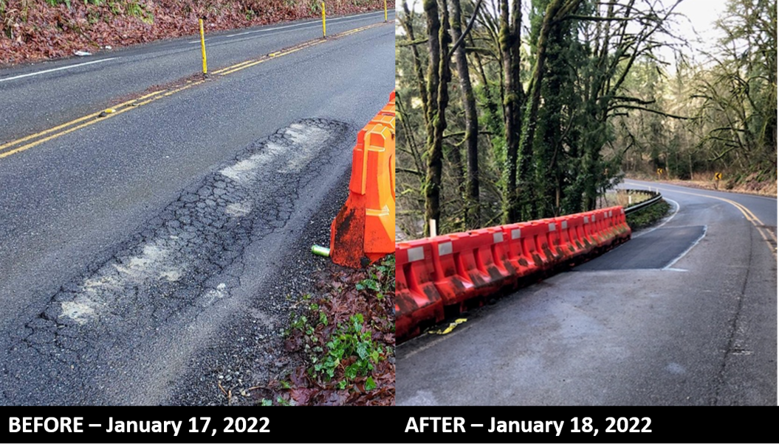

What King County is doing to solve the issue and restore the road to full capacity:
- Road Services must fully repair the support wall to ensure it will not be compromised again.
- Road Services engineers are in the conceptual design phase of this project.
- We expect to begin repairs in summer 2023. At this point, we expect repairs to last approximately three months.
- Originally, we planned to complete the conceptual design phase in 2021 and complete the repairs in 2022. However, recent soil samples of the area yielded data that is different than what our engineers expected. As a result, it is taking longer than usual to design the repair.

Who to contact with questions:
- Broch Bender, King County Road Services, BBender@kingcounty.gov or 206-263-1189.
